A FINAL PROJECT REPORT



**DISCRETE CALCULATOR**

COAL PROJECT- FALL 19

**MEMBERS:**

Muhammad Owais Mushtaq (18K-1177)

Syed Haris Ahmed (18K-1162)

Muhammad Usman Umar (18K-1069)

**INTRODUCTION:**

The Aim of our Project is to implement the few concepts of Discrete Structures [Discrete Mathematics] in our COAL’s project.

We have tried this technique in order to promote the problem solving skills. That’s why we are presenting our project to solve discrete structures problems in an efficient and faster way.

**Flow Chart:**

**Main Features:**

* Converting English Sentences into Logical Expressions.
* Converting Logical Expressions into English Sentences.
* Generating Truth Tables
* Caesar’s Encryption and Decryption

**Converting English Sentences into Logical Expressions:**

This feature aims for converting English Sentences into Discrete Logical Expression as shown by its title. To avoid exceptions we have assumed some constant variables into logical expression.

**For Example:**

English Sentence:



Converting into logical Expression:



**Converting Logical Expressions into English Sentences:**

This feature aims for converting Discrete Logical Expression into English Sentences as shown by its title. To avoid exceptions we have assumed some constant Sentences that fulfill our requirement for converting logical expressions into English Sentences.

**For Example:**

Logical Expression:



Converting into English Sentence:



**Generating Truth Tables:**

For Generating Truth Tables our Project can support the Truth Tables for the minimum of two variables and maximum of three.

**For Example:**

Truth Table of Two variables p and q performing OR Operation

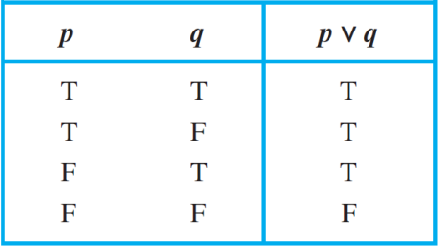

**Caesar’s Encryption and Decryption:**

To make our project more featured we have also introduced Cryptography. For make it specific we have chosen Caesar Cipher’s method of Encryption and Decryption which also termed as Shift Cipher.

**For Example:**

1. **Encryption**

Encrypt the message “STOP GLOBAL WARMING” using the shift  
cipher with *k* = 11.

We get the following encrypted code:

“DEZA RWZMLW HLCXTYR”

1. **Decryption**

Decrypt the message “LEWLYPLUJL PZ H NYLHA ALHJOLY” that was  
encrypted using the shift cipher with *k* = 7.

We get the following decrypted sentence:

“EXPERIENCE IS A GREAT TEACHER.”

**Conclusion:**

This project allowed us to apply the knowledge we obtained in COAL this semester to create a physical working Project.